Duranta + Open5GS GUI
End-to-end network orchestration — architecture and workflow summary

1. Goal
Wrap the existing, CLI-driven Duranta stack (OAI-based gNB and UE) and Open5GS core in a single web GUI so a non-expert operator can configure, launch, monitor, and tear down a complete UE → gNB → core network without typing a single command.

2. Architecture
Three layers sit between the operator and the running network components: a browser-based GUI, an orchestrator backend that owns process/config management, and the three network components themselves, wired together over standard 3GPP interfaces.
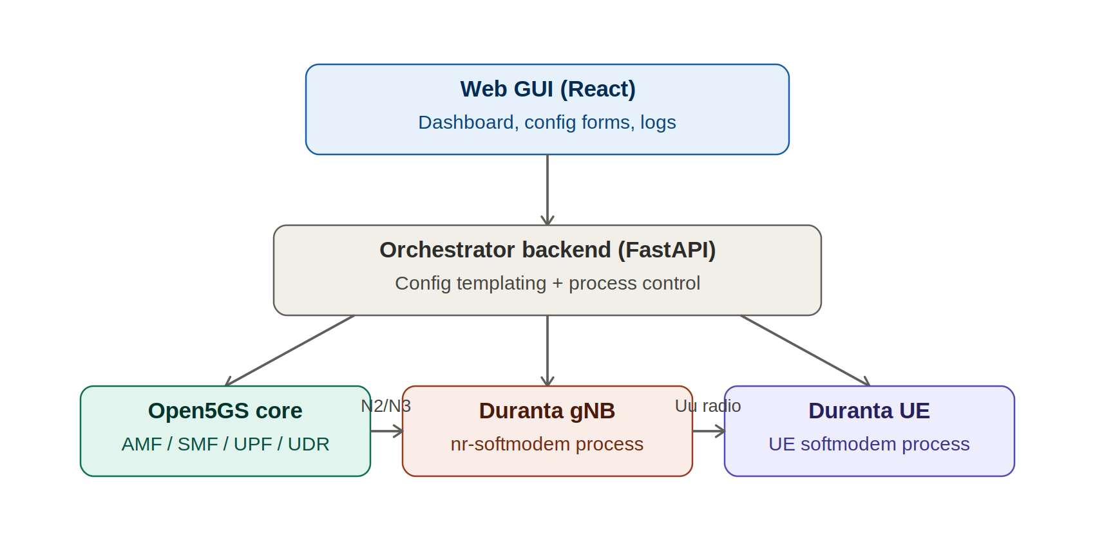
Figure 1. Layered architecture: GUI → orchestrator backend → Open5GS core / Duranta gNB / Duranta UE

Layer responsibilities
- Web GUI (React): configuration forms, live topology dashboard, log viewer, test-tool triggers.
- Orchestrator backend (FastAPI): turns form input into valid .conf/YAML via templating, starts/stops each component in the right order, exposes REST + WebSocket APIs, streams logs and status.
- Open5GS core: AMF/SMF/UPF/UDR etc., containerized; subscriber provisioning can reuse Open5GS's existing WebUI.
- Duranta gNB: the nr-softmodem process, connected to the core over the N2/N3 interfaces.
- Duranta UE: the UE softmodem process, connected to the gNB over the Uu radio interface.

3. End-to-end workflow
The GUI enforces a strict startup order — each network component only launches once the previous one reports ready — and reverses that order cleanly on teardown.
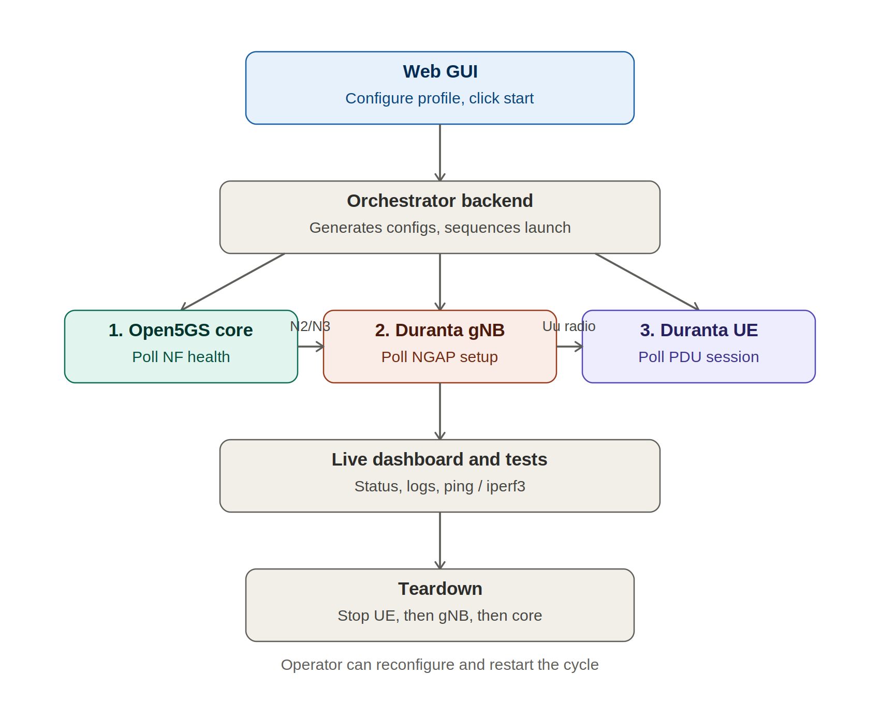
Figure 2. Full process: configure → sequenced launch with readiness checks → live monitoring → ordered teardown

Step-by-step
- Operator configures a network profile in the GUI and clicks start.
- Backend generates the Duranta .conf files and Open5GS YAML from the form input.
- Open5GS core is launched; backend polls NF health endpoints until ready.
- Duranta gNB is launched; backend polls for successful NGAP setup with the AMF.
- Duranta UE is launched; backend polls for registration and PDU session establishment.
- Live dashboard shows status and logs; operator can trigger one-click ping/iperf3 tests.
- On stop, teardown happens in reverse order: UE, then gNB, then core, to avoid orphaned processes or stale core state.

4. Core GUI screens
Screen | Purpose
Network profiles | Save/load PLMN, TAC, band, bandwidth, rfsim vs USRP mode
Core control | Start/stop Open5GS NFs, manage subscribers (IMSI/Ki/OPc)
gNB control | Start/stop, edit config via form, live log stream
UE control | Start/stop one or more UEs, view registration/PDU session state
Topology dashboard | Live status map of Core-gNB-UE, click-through to logs
Test tools | One-click ping/iperf3 with plotted results

Build order (phased)
- Backend wraps existing CLI — REST endpoints for start/stop/status of each component, using your current commands verbatim under the hood.
- Config templating — forms generate valid .conf/YAML instead of you hand-editing files.
- Frontend dashboard — topology view, control buttons, live WebSocket logs.
- Test automation — ping/iperf buttons, subscriber provisioning UI.
- Packaging — Dockerize the whole stack (or ship an installer script) so "anyone" really can run it with one command/click.

Things to get right early
- Startup sequencing: don't use fixed sleeps between "start core" → "start gNB" → "start UE". Poll for a readiness signal (a specific log line, an open port, an NGAP setup response) before enabling the next "start" button.
- RF vs simulation mode: --rfsim is far easier to fully automate and containerize than real USRP hardware, which needs UHD driver access, USB permissions, and real-time scheduling — plan for both modes but get rfsim rock-solid first.
- Privilege handling: if any component needs root/capabilities (real radio, raw sockets), the orchestrator needs a clear, minimal-privilege way to launch those specific processes rather than running the whole backend as root.
- Networking on one machine: Core, gNB, and UE loopback interfaces need distinct IPs/namespaces even in simulation — the GUI should manage this automatically rather than exposing raw interface config to the user.

. Design Principles
• The GUI contains no networking logic.
• The existing C/C++ backend remains responsible for all telecom functionality.
• The Communication/API Layer isolates the GUI from backend implementation details.
• The technology used for the Communication/API Layer can be chosen later (e.g., embedded C++ server, IPC, REST gateway, or other mechanisms) without changing the GUI architecture.

